Physical Science 7: Waves Online Name:____________________ Period: ____
As your teacher directs, draw a transverse (up-and-down) wave here, and label a CREST and a TROUGH on this wave. A crest is a high point, and a trough is a low point.

Challenge Question:
How do the properties of amplitude and frequency affect wavelength?
Activity:
Use online simulations to collect data about three properties of a wave.

- Find a partner and at least one computer. Go to juliewright.weebly.com. Hover over “Science 7” and click on “Electromagnetic Waves”.

- Scroll down to “Other Online Activities” and click on “The boat!” Select a frequency and amplitude and click “GO”. Observe the movement of the boat and the graph of the movement, especially the wavelength. Repeat with different frequency and amplitude settings until you get a good idea of what frequency, amplitude, and wavelength of a wave are.

- Return to the juliewright.weebly.com/electromagnetic-waves.html page. Under the PhET Interactive Simulations section, click on the “Wave on a String” link. Click on the green “Run Now!” button and wait till the simulation opens.

- Spend five minutes exploring the simulation with your partner. Be sure to click on all the buttons and move things that can be moved.

- For the first set of investigations, we will look at amplitude.
  - you need to be on
  - The rest of your screen should be set up as shown on the back of this page. You can type in the number settings.
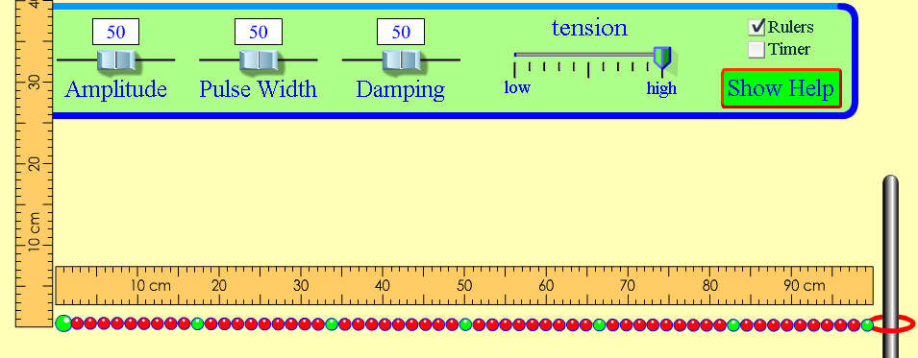
Using  to move the wave, collect data to fill in this table:
Amplitude setting | Height of wave at the start  (be sure your ruler is lined up correctly) | Distance ring moves on pole (end)
100
50
5
Discuss what happened to the energy at the end of the wave when we changed the amplitude. Be prepared to share your thoughts on this with the class.
- For this next part we will investigate wavelength.
  - You need to be on
  - Set Amplitude to 100 and Frequency to 70.
  - The rest of your screen should be set up like we did at the start of step 4.
  - Try out the pause and  buttons. This may be useful for collecting data.
  - Collect data on wavelengths (crest to crest, as shown below) for two different waves. Then change the amplitude to something else and do it again.
WAVELENGTHS WHEN AMPLITUDE IS 100: _____ cm and _____ cm
WAVELENGTHS WHEN AMPLITUDE IS ______: _____ cm and _____ cm

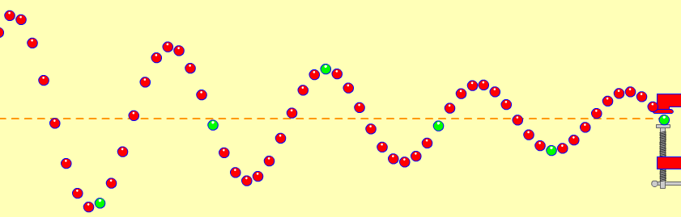
- For the third set of investigations, we will look at frequency.
  - you need to be on
  - open both the ruler and timer
  - controlled variables: amplitude and damping should be on 50 and tension stays on “high”
  - Remember, to stop or slow the wave use pause/play and .
- With a partner, look over the data table below and discuss how you will collect the data you need.
- Before you begin… try a little practice using the timer:
- Turn the timer on, off and reset the timer while waves are moving.
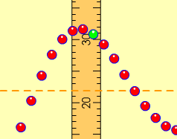
- Practice counting waves passing a given point:
- Move the vertical ruler so that it is along the wave’s path. This will be the point where you watch waves pass and count them. Count 5 waves passing the ruler. Change the frequency and count again.
- Fill in the table by working together counting the waves and using the timer.
Data:
Frequency simulation setting | Time interval | Number of waves: |  |  | Average number of waves counted in 10 second period (add up trials, divide by 3) | Frequency*: number of waves in 1 second (see note below)
Frequency simulation setting | Time interval | Trial #1 | Trial #2 | Trial #3 |  | Frequency*: number of waves in 1 second (see note below)
50 | 10 seconds
10 | 10 seconds
100 | 10 seconds
*To find frequency, divide the average number of waves counted by the time interval (10).
9. Fill in the blanks: Our data show that the higher the number chosen for the frequency on the slider, the _________________ the number of waves passing a given point in a certain amount of _________________.
10. Select “Manual” to show a wrench you can move up and down to make a wave.
How do you move the wrench to make a wave with a high amplitude and low frequency?

How do you move the wrench to make a wave with a high frequency and low amplitude?
11. Use arrows, or draw a new wave, to show what will happen when the amplitude is increased:
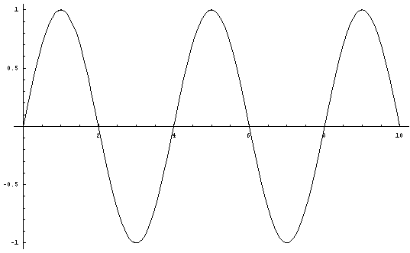
Line of --origin------
12. Use arrows, or draw a new wave, to show what will happen when the frequency is increased:

Line of --origin------
13. Which picture shows how increasing the frequency in the wave will affect the wavelength?

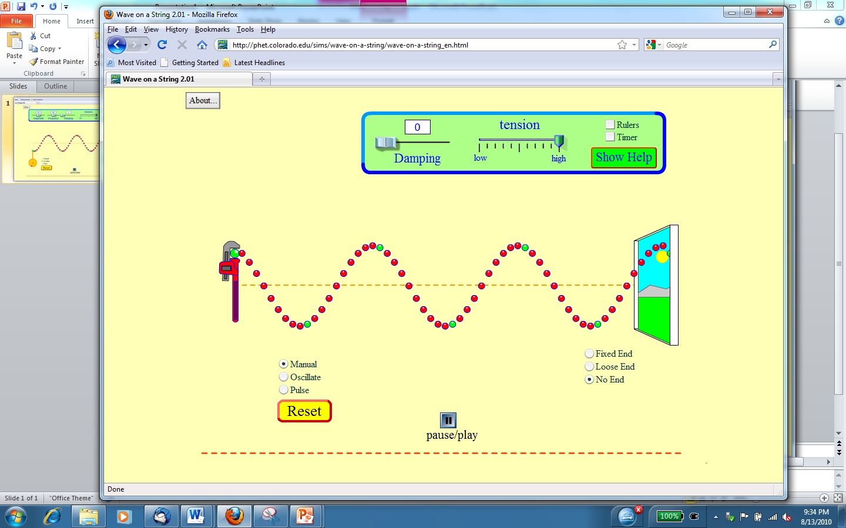
- 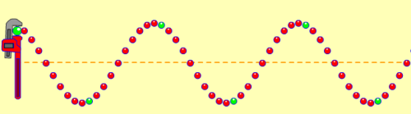 C. 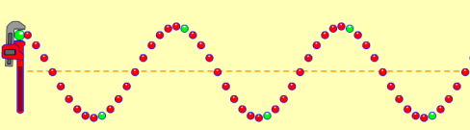

- 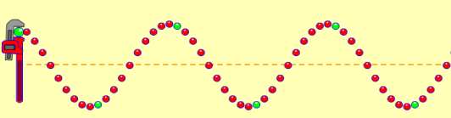 D. 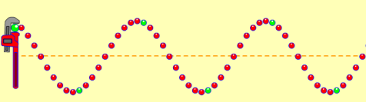

EXTRA CREDIT #1. Investigate to determine what happens to the wavelength when the frequency is doubled. Describe your data (which should include at least 4 frequencies) and conclusions here.

EXTRA CREDIT #2. What does “damping” do? (Be sure to investigate with multiple settings for the other things.)

