Math 6 Probability #1 Name: ______________________________
Ms. Wright June 2013 Period: ____

(Much of this material is from our student text Connected Mathematics 2: How Likely Is It?)

How do you make decisions? Suppose you are deciding whether to wear a raincoat. Would you ask “How likely is it that it will rain today?” Suppose you are deciding whether to buy a raffle ticket. Would you ask “What are the chances that I will win the raffle?”

To make some decisions, you consider the chance, or likelihood, that something will happen. The mathematical word for chance is probability. You may listen to the weather forecast to decide whether you will wear a raincoat to school. In some cases, you may even let chance make a decision for you, such as when you roll a die (number cube) to see who goes first in a game.

Finding probabilities can help you understand past events and make decisions and predictions about future events.

Today you will find an experimental probability to predict the most likely and second most likely colors of jellybeans that will be drawn from a bag of 120 jellybeans. Experimental probabilities are calculated from data drawn from experimental trials (measurement opportunities, like rolls of a die or ticket drawings). For instance, if you flipped a coin 30 times (30 trials) and the head side landed up 16 times, the experimental probability of the head side landing up is 16 out of 30, or . (Is this bigger or smaller than what you think the probability of heads should be?)

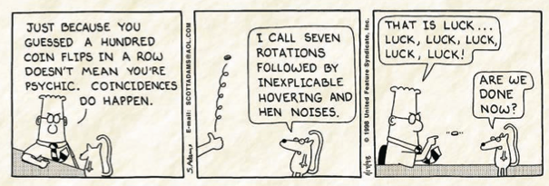In general, if you are measuring the probability of a desired result, you can run trials and keep track of which ones were favorable (meaning they gave the desired result). The experimental probability of the desired result is then
P(desired result) = (for example, P(heads) = ).
Now for the jellybean experiment! Your group will be called over to make a secret drawing of 12 jellybeans from a bag of 120. (SSSHHH! Hide your results from spies from other groups!)

Record your jellybean colors here:

1. _________________________ 2. ____________________________ 3. ___________________________

4. _________________________ 5 ____________________________ 6. ___________________________

7. _________________________ 8. ____________________________ 9. ___________________________

10. _________________________ 11 ____________________________ 12. ___________________________
Make your best predictions to each of these questions based on the data you have so far.

- If someone draws a jellybean randomly from the bag and you are trying to guess what color they will draw, are all colors equally likely? If not, which do you think is most likely and second most likely, and why?
- What is the experimental probability of drawing each color, based on your results? (Write each color, its probability expressed as a fraction, and then, if possible, reduce the fraction.)
- Convert the fractions in Problem 2 to percents to express the probability of drawing each color as a percent. (Example: if the fraction can be reduced to ¼, the probability is 25%.)
- Can you think of a way to use your probabilities from Problem 2 or Problem 3 to predict how many jellybeans of each color are in the mystery bag? If so, try it here!
When everyone in your group has gotten this far, tell me and wait for instructions for what to do next…

New information about jellybeans and colors:

Record your jellybean colors and the numbers of each color in the first two columns:

Color | # | Exp. Probability (fraction) | Exp. Probability (%)
Make your best predictions to each of these questions based on the data you have so far.

- If someone draws a jellybean randomly from the bag and you are trying to guess what color they will draw, are all colors equally likely? If not, which do you think is most likely and second most likely?

- What is the experimental probability of drawing each color, based on your results? In the table, record these probabilities expressed as a fraction, and then, if possible, reduce the fraction. (Remember that you have increased the number of trials.)
- In the right column of the table, convert the probability fractions to percents to express the probability of drawing each color as a percent. (Example: if the fraction can be reduced to ¼, the probability is 25%.
- Can you think of a way to use your probabilities to predict how many jellybeans of each color are in the mystery bag of 120 jellybeans? If so, try it here!
Math 6 Probability HOMEWORK #1 Name: ______________________________
Ms. Wright June 2013 Period: ____

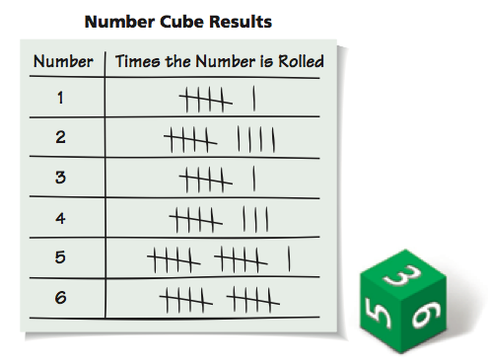
- Colby rolls a six-sided die (number cube) several times. She records the result of each roll and organizes her data in the table below.
a. What fraction of the rolls are 2’s? What percent is this?
b. What fraction of the rolls are odd numbers? What percent is this?
c. What percent of the rolls is greater than 3?
d. Suppose Colby rolls the number cube 100 times. About how many times do you think she can expect to roll a 2? Explain.
e. If Colby rolls the number cube 1,000 times, about how many times do you think she can expect to roll an odd number? Explain.
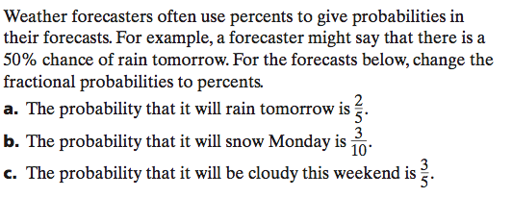
2.
- KEY
36 dark red = 3/10 = 30%
30 yellow = ¼ = 25%
15 black = 1/8 = 12.5%
15 orange = 1/8 = 12.5%
12 pink = 1/10 = 10%
12 green = 1/10 = 10%

